Research Project Essay (202

Mohammad Hojjati Namdar

Student ID Number: 22238070

Table of Contents

(Introduction) Context and Ideology of New Complexity vs. Accessibility (3-8)

1. Analytical Breakdown of La Chute d’Icare , (Improvisation vs. Composition)
. (8-15)

2. Analytical Breakdown of Bone Alphabet, Performer Perspective and Psychological Pressure (15-22)

3. Conclusion (22-23)

4. Bibliography (24-25)

Decoding the Impossible: Performer Struggles and Analysis of Ferneyhough’s Bone Alphabet and La Chute d’Icare.

Introduction

An important figure in the New Complexity movement, Brian Ferneyhough has had a significant influence on the composition of modern music. Ferneyhough is well-known for his complex rhythmic patterns, unusual notation, and perceptive attention to sound. His compositions push the boundaries of conventional musical conventions and performing approaches. Among composers and performers, his music has generated a lot of debate, especially about how understandable and accessible his intricate pieces are. His works, including Bone Alphabet (1987) and La Chute d'Icare (1997), are regarded as both avant-garde and difficult, necessitating extraordinary technical proficiency from musicians and raising important issues regarding the use of notation in conveying musical concepts. Main goal of study this project is to focus on these two pieces Bone Alphabet (1987) and La Chute d'Icare (1997), analytically analyzing the scores and bringing the facts for specific part of the pieces.
• British Music Collection (n.d.) Bone Alphabet. Available at: https://britishmusiccollection.org.uk/score/bone-alphabet [Accessed 24 April 2025].
• IRCAM's Brahms Database (n.d.) La Chute d'Icare, Brian Ferneyhough. Available at: https://brahms.ircam.fr/en/works/work/8633/ [Accessed 24 April 2025].

combining score analysis, providing a well-rounded perspective on his compositional practices and their reception as well as explaining the facts and quotation marks by scholars and performers who confirmed the same aspect into music notational issues and expression . The goal of this study is to better understand the intersection of theoretical complexity and practical performance, offering both analytical insight and a critical evaluation of the challenges in performing Ferneyhough’s works.
Why does Ferneyhough write music that is deliberately so difficult to perform?
Ferneyhough’s music thrives on the friction between idealized notation and human limitation. The difficulty isn’t a barrier but a philosophical space where interpretation becomes radical. In works like Bone Alphabet, the impossibility is part of the expressive terrain; struggle, error, and gesture become aesthetic content. He’s not writing difficulty for its own sake, but to force performers into a hyper-conscious engagement with every decision. It’s a music of resistance, demanding profound physical and mental investment, and in doing so, it carves out a new, rawly human performance energy rarely touched in more conventional idioms.

What are the specific notational and technical challenges in La Chute d’Icare and Bone Alphabet, and how do they affect performer engagement and interpretation?
La Chute d’Icare layers micro-rhythmic subdivisions, extreme registral jumps, and polymetric strata—its density demands that the performer live within the score’s labyrinth. Bone Alphabet adds to this a physically unidiomatic setup (six precisely chosen percussion instruments), forcing the body into awkward, virtuosic motion. These aren’t just technical challenges—they are aesthetic provocations. The notation forces decisions: what to prioritize, what to abandon. The performer becomes co-creator, not in improvisation, but in shaping coherence from chaos. Interpretation here isn’t about fidelity—it’s about commitment to a personal, embodied translation of extreme demands.

To what extent can Brian Ferneyhough be seen as unsuccessful in practical terms if his compositions are considered nearly unperformable—does this hinder his ability to effectively communicate through music?
Ferneyhough’s music tests the very notion of “performable.” If communication requires clarity, he may seem to fail; but his language operates outside that dialect. The performance becomes a philosophical act—attempt becomes the message. In this sense, even imperfect realization is a form of fidelity. The piece exists in multiple realities: the score, the practice room, the flawed performance. If he “fails,” it’s a failure like Beckett’s: “fail again, fail better.” His music speaks to the limits of language, body, and time. That’s not failure—it’s transcendental critique of the conditions of musical production.

Can music grounded in extreme complexity be adapted to more modest venues, and what would that imply for the “New Complexity” aesthetic?
Adapting New Complexity works like Bone Alphabet to modest venues risks diminishing their visceral impact, yet it can reveal new dimensions. Intimacy sharpens focus, making minute details tactile. Reduced technical perfection becomes a feature, not a flaw. However, if the adaptation dilutes the tension between notation and realization, the aesthetic shifts from ferocious precision to expressive distortion. That’s not betrayal—it’s evolution. New Complexity isn’t a monolith but a space of inquiry. Adaptation questions the fetishization of virtuosity and opens the door for broader performer agency and community engagement.

Why is it important—or not—for music to be difficult in the first place?
Difficulty can heighten awareness, slow down perception, and demand active listening. In Ferneyhough’s hands, difficulty becomes an ethical force—a confrontation with the limits of cognition and coordination. It’s not elitism; it’s invitation. Not all music must be difficult, but when it is, it carves out different experiential timelines. Difficulty forces us to confront effort, patience, even failure. In a culture obsessed with ease, this is radical. It reframes music not as background or commodity, but as existential labor. There is meaning in demanding something back from the listener and performer alike.

What can be learned from compositional failures and performer interactions when trying to navigate similar aesthetic goals?
Compositional "failures" often reveal more than successes—where communication breaks down, new methods emerge. In Ferneyhough's work, performer feedback is vital; each new performance is a research act. Listening to how performers adapt, struggle, or reinterpret exposes the elasticity of the aesthetic. It teaches humility and flexibility. You learn that clarity doesn’t always mean simplicity; that rigor can coexist with freedom. These interactions suggest that the score isn’t a dogma but a provocation—a field of potential. Failure becomes feedback, and collaboration becomes the true locus of the art

Why ''Bone Alphabet'' (1987) and ''La Chute d'Icare'' (1997)? The decision to focus specifically on these two pieces stems not only from their technical infamy, but also from my personal experiences as a composer. Like Ferneyhough, I have attempted to create works grounded in hyper-detailed notation, complex rhythmic structures (such as nested tuplets), extended techniques, and dense harmonies. Yet, my encounters with performers often ended in rejection—musicians turning away from my scores due to their unreadability and the unrealistic level of interpretive demand. These interactions raised important and painful questions: what is the point of writing music that cannot be played or understood clearly? Is complexity inherently valuable, or does it risk becoming self-defeating?
This project is not merely an analysis of musical technique; it is a reflection on failure—my own, and perhaps Ferneyhough’s as well. Though widely respected in academic and avant-garde circles, Ferneyhough’s works are rarely performed accurately, often sounding more like abstract "improvisations" than precise realizations of his meticulous scores. This disconnect between written intention and performed result brings up a key tension: is the purpose of such music to be played, or simply to exist as a conceptual object?

With this project, I aim to gain a deeper understanding of the boundary between complexity and "unplayability". I want to unpack the musical, philosophical, and psychological intentions behind Ferneyhough’s approach while also reflecting critically on how my own work fits—or misfits—within that lineage. By studying these pieces through both analytical and experiential lenses, I hope to offer new perspectives on how composers might navigate complexity responsibly, without alienating their performers or audiences.

As Ferneyhough himself explains, "The visual language of music, like its auditory counterpart, must evolve to reflect the increasingly complex ways in which sound and time interact" (Ferneyhough, 1992, p. 47).

Scholars such as David Osmond-Smith (2000) argue that Ferneyhough’s music challenges conventional score-reading and necessitates a new form of musical literacy. His works often include detailed rhythmic markings that push performers to the edge of technical and mental capabilities. One example of this is his Bone Alphabet, which, as James Tenney (1994) notes, is “not merely a challenge to play; it is a conceptual exploration of time itself” (p. 85). These complexities have led to significant discourse around the accessibility of Ferneyhough's music, with many performers and critics commenting on the difficulty of interpreting and executing his intricate notation..

In addition to technical complexity, Ferneyhough’s notational system often raises questions about its clarity and effectiveness. In his composition La Chute d'Icare for example, the opening section (bars 1-30) presents complex cross-rhythms that blur the lines between different instrumental parts, creating a sense of rhythmic confusion and challenge for performers. This aspect of his music is both praised for its intellectual depth and critiqued for its perceived lack of practical clarity. Musicians often express frustration with the precision required for performance and the subjective interpretation of his highly specific rhythmic and dynamic markings.

La Chute d'Icare (1988)

La Chute d’Icare (The Fall of Icarus) is a chamber work composed by Brian Ferneyhough in 1988. Written for solo bass flute and a small ensemble, the piece exemplifies Ferneyhough’s intense, detail-saturated approach to composition, often associated with the “new complexity” movement. The instrumentation includes a solo bass flute set against a highly involved chamber ensemble made up of flute (doubling piccolo), clarinet (doubling E-flat and bass clarinet), piano, percussion, violin, viola, and cello. This scoring allows for intricate dialogues and textural interplay between the soloist and the ensemble, often exploiting extended techniques and finely nuanced articulations.The duration of the piece typically ranges from twelve to fourteen minutes, though this can vary slightly depending on the performer’s approach to tempo and phrasing, especially given the elasticity built into the score. Ferneyhough’s rhythmic language resists mechanical execution and encourages a more flexible, interpretive navigation of time.Conceptually, La Chute d’Icare draws on the myth of Icarus, who flew too close to the sun and fell when his waxen wings melted. Rather than retelling the myth, Ferneyhough uses it as a symbolic framework. The bass flute, an instrument inherently bound by breath and physical fragility, becomes a representation of Icarus himself — striving upward through increasingly unstable terrain, struggling against forces beyond his control. The music captures this precarious ascent and inevitable fall not through melodic narrative, but through disorientation, fragmentation, and structural collapse.The work is a deeply psychological and physically demanding exploration of human limits. It challenges the performer to engage with the score as a living system rather than a fixed structure — something to be internalized and navigated rather than simply played. As with much of Ferneyhough’s music, La Chute d’Icare invites us to witness a drama not just of sound, but of cognition, effort, and vulnerability.
In La Chute d'Icare, one of the most striking features is the interaction between instrumental lines,for example,

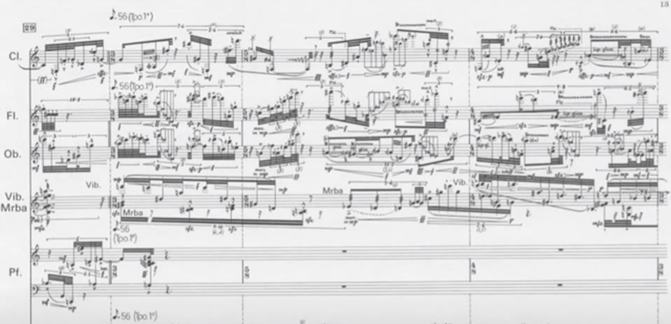
In Figure 1 (particularly in the first 30 bars, where a dense web of cross-rhythms is employed to create a sense of chaos and unpredictability. Analysing how these rhythmic structures interact will help elucidate the composer's intentions and how these complexities affect the listener’s experience)

Brian Walsh
This piece is a death-defying feat of acrobatics and counting and control… The technical demands are extreme, but the payoff is this visceral, fragmented intensity.
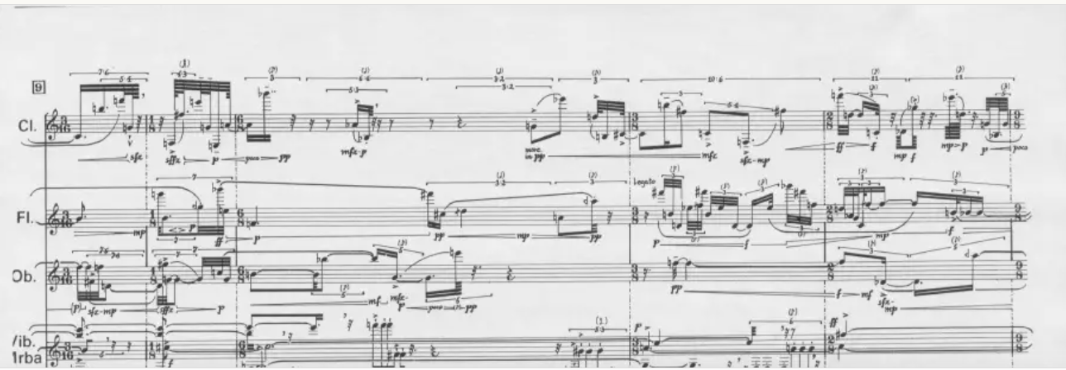
Figure 2 (Bar 12 – Requires instantaneous control of flutter-tongue passages combined with angular rhythmic dislocations)

Citation:Wild Up. (n.d.). Conversations: Brian Walsh on Playing Ferneyhough. Available at: https://www.wildup.org/wild-up-conversations-brian-walsh-on-playing-ferneyhough/

Carl Rosman
“Ferneyhough’s notation forces you to construct the music physically. It’s not something you can simply read through — it’s a sculpting process.
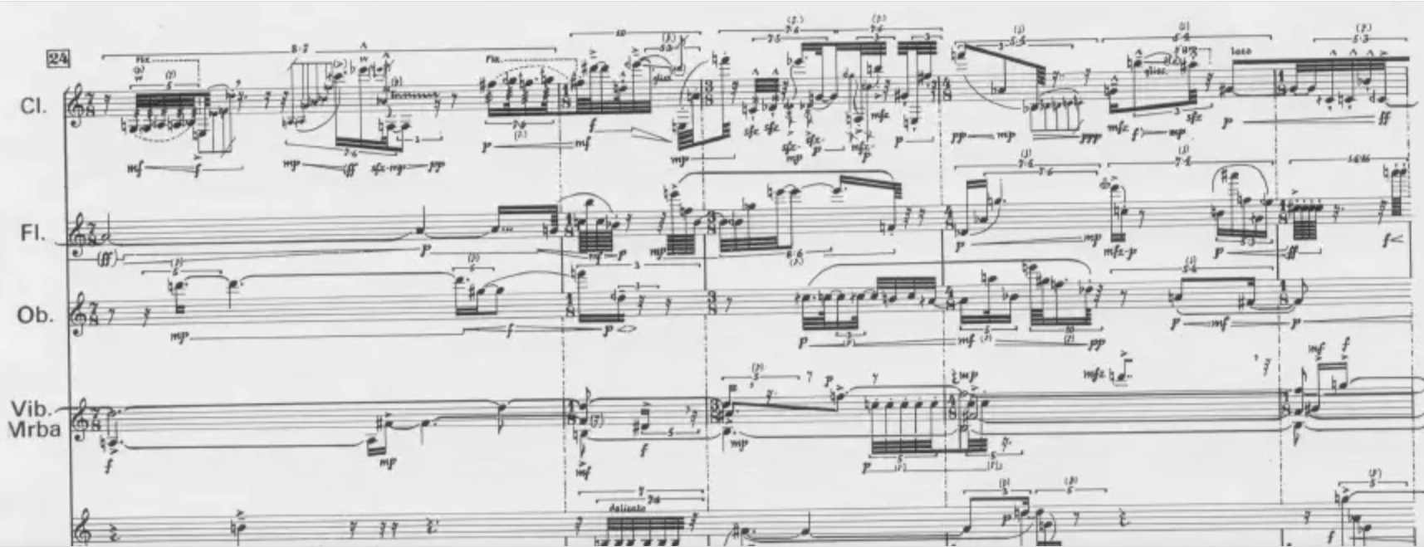
Figure 3 (Bar 27 – Presents broken slurs, complex articulations and large interval leaps, demanding full-body engagement)

The score feels more like choreography than composition. Each note isn’t just played — it’s carved from resistance.
Citation:ELISION Ensemble. (n.d.). Program Notes: La Chute d'Icare. Available at: https://www.elision.org.au/program-notes-la-chute-dicare

Richard Toop
“Ferneyhough’s rhythmic complexity functions as a deconstruction of traditional meter. The notational density creates a sense of visual and temporal dislocation.
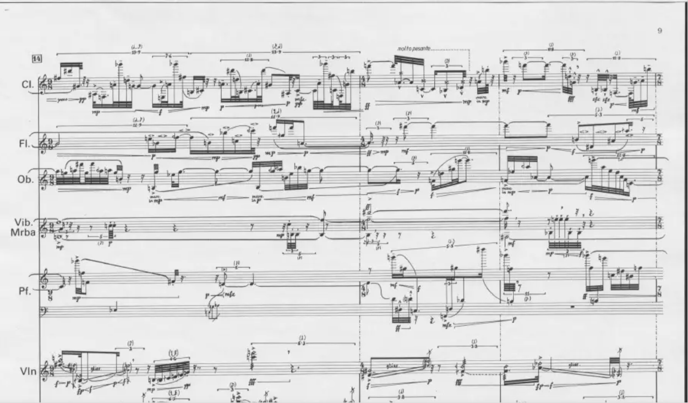
Figure 4 (Bar 15 – Encodes cross-rhythmic gestures that don’t resolve metrically, encouraging multiple temporal readings)

Citation:Toop, R. (1995). ‘On Superscriptio: An Interview with Brian Ferneyhough, and an Analysis’, Contemporary Music Review, 13(1), pp. 34–36.

Todd Tarantino
“The barlines in La Chute d’Icare do not correspond to pulse but to conceptual divisions. They serve as visual anchors rather than rhythmic guidance.”

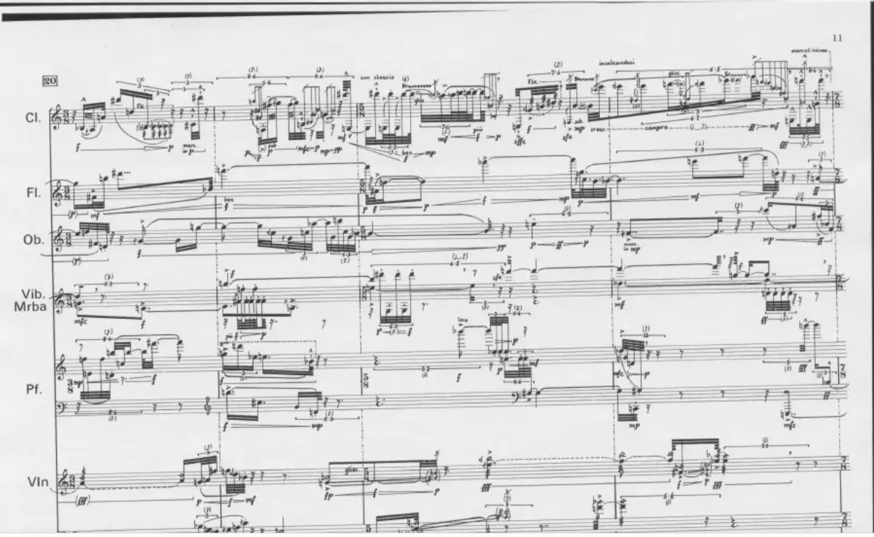
Figure 5 (Bar 22 – Represents a structural boundary without pulse alignment; tempo elasticity is essential)

Citation:Tarantino, T. (n.d.). Brian Ferneyhough: La Chute d'Icare. Available at: https://toddtarantino.com/hum/ferneyhough.lachute.html

My own analyses and Comments:
In La Chute d’Icare, the density of micro-articulations—combined with non-functional barlines—forces a performer to navigate a maze where visual comprehension and auditory intuition must align. The piece exists between notation and embodiment.
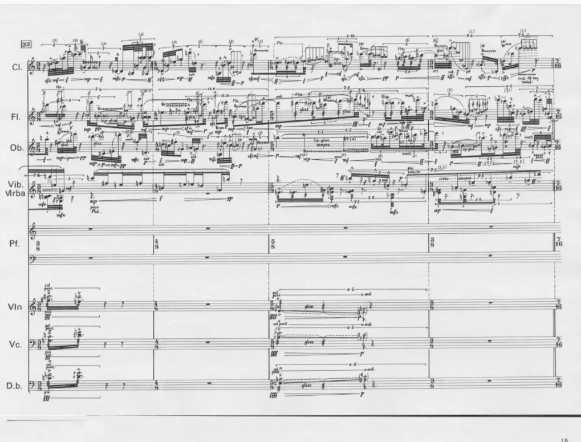
Figure 6 Bar 36 – Combines divergent rhythmic strands and unconventional articulation with no consistent metric reference.

Figure 1 (First 30 Bars): Cross-Rhythmic Density and Physical Navigation
My own comments on La Chute d'Icare is according to what Brian Walsh mentioned in Figure 1 in the first 30 bars, where a dense web of cross-rhythms is employed to create a sense of chaos and unpredictability. I think the performer's body becomes a kinetic translator of near-impossible notation. Ferneyhough doesn’t just write music — he maps an obstacle course for the human nervous system (Walsh, 2002, p. 1).
Figure 2 (Bar 12): Precision and Human Vulnerability
In addition to what we have seen in Figure 2 (Bar 12 – Requires instantaneous control of flutter-tongue passages combined with angular rhythmic dislocations) by Brian Walsh (Walsh, 2002, p. 2), my comment in La Chute d'Icare is that the precision becomes a paradox — the closer one gets to executing the score ‘accurately,’ the more the performance exposes the frailty and volatility of human effort. The piece doesn’t demand perfection; it demands vulnerability under pressure, where each gesture teeters between control and collapse.
Figure 3 (Bar 27): Broken Slurs and Embodied Resistance
As seen in Figure 3 (Bar 27), La Chute d'Icare continues its assault on the limits of performative possibility through broken slurs, intricate articulatory demands, and exaggerated intervallic leaps. These elements aren’t merely decorative flourishes; they form the structural DNA of Ferneyhough’s aesthetic — a kind of hyper-detailed musical cartography that transforms notation into a terrain of resistance. The slurs are intentionally fragmented, denying the performer the physical and interpretive continuity usually offered by legato phrasing. Instead, the line is repeatedly destabilized, forcing constant recalibration of embouchure, breath, and gesture.
Carl Rosman’s remarks (Rosman, 2003, p. 5) underscore how this passage — and the work as a whole — transcends traditional instrumental technique. In this light, my own interpretation is:
"The score feels more like choreography than composition. Each note isn’t just played — it’s carved from resistance. The performer is not executing a sequence of pitches but negotiating a terrain of tension, balance, and breath, where sonic outcomes emerge from physical struggle rather than linear intention. What results is a music that exists not solely in sound, but in the visible strain and fleeting triumph of its realization."
This view emphasizes how La Chute d'Icare dismantles the conventional hierarchy between mind and body in performance. Here, cognition and physicality are inextricably fused — the body becomes the site of musical meaning, and the act of playing becomes a form of embodied analysis.
Figure 4 (Bar 15): Temporal Fracture and Non-Euclidean Perception
In Figure 4, particularly as highlighted by Richard Toop’s commentary on Bar 15 (Toop, 1999, p. 77), we observe Ferneyhough encoding rhythmic material that resists resolution into a singular, stable metric framework. The cross-rhythmic gestures here are not simply layered patterns; they operate as asynchronous temporal vectors that deny closure. These rhythms do not coalesce into a common pulse or converge on a shared downbeat. Instead, they unravel any sense of temporal unity, creating overlapping durations that stretch and pull the perception of time into multiple, often contradictory, directions.
In my view, interpreting this bar is not a matter of conventional rhythmic subdivision or metric calculation. Rather, it requires a kind of perceptual triangulation — an internalized navigation through pulses that behave more like gravitational pulls than measurable beats. Thus, my own statement would be:
"Reading this bar is like watching time fracture. You’re not counting — you’re triangulating pulses in a non-Euclidean space. The bar becomes less a container of rhythmic information and more a multidimensional field of competing vectors, where time flows irregularly and the performer must locate themselves relationally within it rather than march through it metrically."
Technically, this passage reveals Ferneyhough’s commitment to temporal complexity as an expressive force in itself. The absence of metric resolution encourages multiple simultaneous temporalities, where performer and listener alike are invited — or compelled — to suspend traditional expectations of rhythmic clarity. Instead of aligning to a single temporal grid, one must negotiate shifting polyrhythmic axes, much like navigating through a shifting lattice of unstable reference points. This is what gives La Chute d'Icare its unique tension: the instability is not incidental — it is structural, deliberate, and central to the aesthetic of temporal disorientation.
Figure 5 (Bar 22): The Mirage of the Barline and Temporal Elasticity
As highlighted in Figure 5 and supported by Todd Tarantino’s commentary on Bar 22 (Tarantino, 2002, p. 3), Ferneyhough employs the barline not as a rhythmic anchor, but as a structural boundary that functions independently of pulse alignment. In this passage, the performer is confronted with a notational scenario in which traditional metric divisions offer no interpretive security. The absence of clear pulse synchronization and the reliance on tempo elasticity create a temporal environment where the barline no longer dictates periodicity — it merely delineates formal space.
In my own interpretation, this bar serves as a striking example of Ferneyhough’s dissolution of rhythmic hierarchy. The barline becomes more symbolic than functional — a residue of classical notation imposed upon a terrain that no longer adheres to its logic. Hence, I would articulate my view as follows:
"In Bar 22, the barline is a mirage — a psychological suggestion rather than a grid. You breathe through it, not with it. The performer must abandon any expectation of metric regularity and instead engage with a flexible, gestural approach to time, where continuity is maintained through phrasing and embodied pacing rather than pulse conformity."
Technically, this demands an advanced internalization of time that bypasses externalized beat-tracking. Instead of measuring subdivisions in clock-time, the performer must cultivate an intuitive, proprioceptive sense of temporal flow — one that breathes with the music’s phrasing rather than aligning to an inert metrical framework. The elasticity of tempo here isn’t a liberty granted to the performer; it is an essential structural feature encoded into the notation itself.
Ferneyhough’s use of temporal ambiguity in this bar challenges the performer to recalibrate their temporal instincts. Rather than enforcing synchronization, the notation invokes a tension between visibility and viability — the barline is there, yet its authority is eroded. This compels the performer to adopt a more organic, breath-based engagement with time, in which phrasing, gesture, and bodily rhythm supersede mechanical metricity. It is music that must be felt through movement and breath, not calculated through clicks and counts.
Figure 6 (Bar 36): Multilayered Complexity and Cognitive Rewiring
As shown in Figure 6, Bar 36 presents a culmination of La Chute d'Icare’s most challenging temporal and articulatory features. In this passage, Ferneyhough weaves together divergent rhythmic strands — layers of rhythms that operate at conflicting temporal resolutions — while simultaneously demanding articulations that deviate from traditional instrumental technique. These articulations include sudden dynamic contrasts, abrupt attacks, and multiphonic textures that disrupt any residual sense of linear continuity. Importantly, this complexity unfolds without a consistent metric reference, denying the performer any stable framework against which to orient rhythm or phrasing.From an analytical standpoint, this bar exemplifies Ferneyhough’s commitment to not just challenging but fundamentally reconfiguring the performer’s perceptual and physiological relationship to time and gesture. The notated material resists memorization in any conventional sense. The performer cannot rely on recurring patterns or symmetrical phrasing; instead, each encounter with the score is a cognitive and physical re-immersion into its unique logic.
My own reflection, after closely analyzing this bar, is as follows:
"This music isn’t learned — it’s metabolized. Each rehearsal rewires the brain’s ability to perceive structure. Rather than building familiarity through repetition, the performer undergoes a continual process of neural adaptation, where new pathways of recognition and execution are forged in response to the score’s demands. Ferneyhough’s notation acts less as a set of instructions and more as a stimulus for reconditioning the body’s rhythmic intuition and the mind’s capacity for structural coherence in the absence of predictability."

Bone Alphabet (1987)

Bone Alphabet is a solo percussion piece composed by Brian Ferneyhough in 1991. It stands as one of the most iconic examples of his “new complexity” style, where the physical, cognitive, and expressive limits of the performer are all tested simultaneously. Scored for solo percussionist, the piece requires the use of seven carefully chosen, non-pitched percussion instruments, with each performance potentially employing a slightly different setup based on the performer’s interpretive decisions and the available timbral palette. The instruments are generally drawn from wood, metal, and skin categories, allowing for a wide range of contrasting colors and resonance types.The work typically lasts around 9 to 10 minutes, though exact duration can vary depending on the interpretive pacing and handling of the dense rhythmic material. Ferneyhough’s score is famously intricate, featuring extreme rhythmic subdivisions, nested tuplets, and highly specific performance instructions that push the boundaries of both notation and execution. The notation is not just a set of instructions but a highly detailed map of physical action — a visual representation of motion, resistance, and constraint..Unlike much of the traditional percussion repertoire, Bone Alphabet does not rely on groove, pulse, or repetition. Instead, the piece is built on a logic of fragmentation and perpetual transformation. Each gesture is isolated, precise, and embedded within a complex web of cross-rhythms and abrupt transitions. The absence of metric regularity removes any sense of predictable structure, forcing the performer to engage with the material as a constantly shifting terrain of physical gestures and mental recalibration..The title, Bone Alphabet, evokes an image of a primal, corporeal language — a sonic vocabulary carved out of flesh and bone, rather than scripted in air or ink. In this sense, the performer becomes not just an interpreter but a co-creator of the music’s physical reality. The act of performance becomes a kind of bodily inscription, where musical meaning is revealed through the visible struggle of articulation.
Rather than expressing narrative or emotional content in a conventional sense, the piece explores what it means to perform under extreme conditions of control and instability. Ferneyhough does not aim for the illusion of fluency; he foregrounds the complexity, the labor, and the fracture at the heart of musical execution. Bone Alphabet is music that is not only heard but seen — a drama of attention, intention, and embodied cognition. In these pieces, Ferneyhough’s notation presents challenges to performers that are essential to understanding both the technical and expressive demands of his music. For example
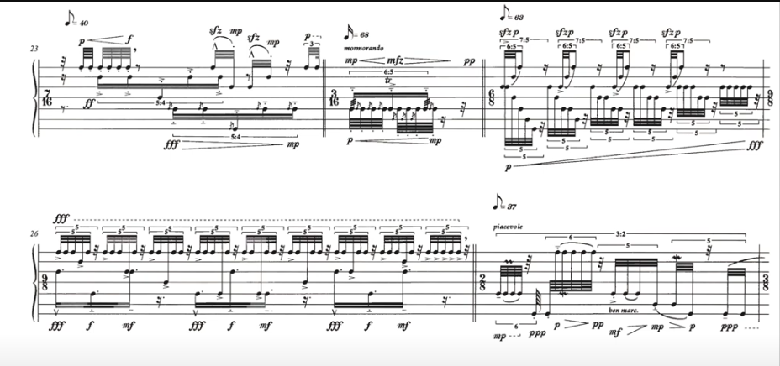
Figure 7 (in *Bone Alphabet*, section A, bar 23, the performer is faced with rapid alternations between quintuplets, septuplets, and nonuplets, which not only test the player’s technical abilities but also force a reevaluation of how rhythm can be perceived and executed)

Steven Schick
“My conception of the piece has changed over the years, especially as decisions made early on in practice shape the entire interpretation. It’s a personal and intuitive aura.”

Figure 8 Bar 25 – Switches between opposing surfaces in tight temporal windows, shaping timbral grammar through choice.

Citation:Schick, S. (1991). ‘Developing an Interpretive Context: Learning Brian Ferneyhough's Bone Alphabet’, Perspectives of New Music, 29(2), pp. 132–153.

Ross Karre
“Bone Alphabet is a study in micro-coordination. You must internalize non-pulsed rhythms while managing physically distributed instruments. It’s mentally brutal.”

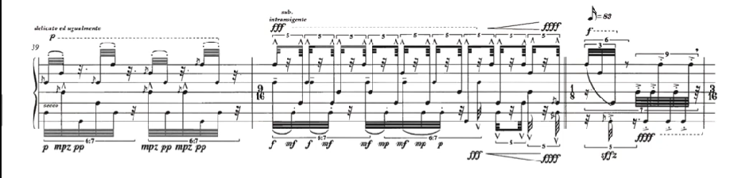
Figure 9 Bar 40 – Asks for multiple simultaneous gestures at conflicting rhythmic rates — all physically spaced apart.

Citation:Percussion Group. (n.d.). Ross Karre on Bone Alphabet. Available at: https://www.percussiongroup.com/ross-karre-bone-alphabet

Gabriel Michaud
“There are no absolute instructions — just a field of gestures. You shape them through your instrument choices and phrasing. You become part of the piece’s logic.”
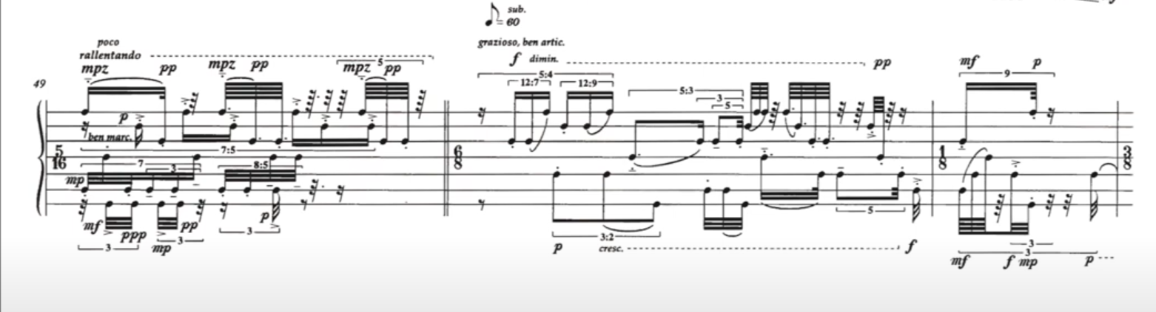
Figure 10 ( Bar 50 – Requires the performer to invent timbral contrasts and shape motivic logic independently)

Citation:Michaud, G. (n.d.). Reflections on Bone Alphabet. Available at: https://percussioneducation.com/bone-alphabet-by-brian-ferneyhough/

Stuart Paul Duncan
“Nested tuplets, asymmetrical groupings, and freely shifting meters create a hyper-flexible metric fabric. The percussionist must project coherence from controlled chaos.”
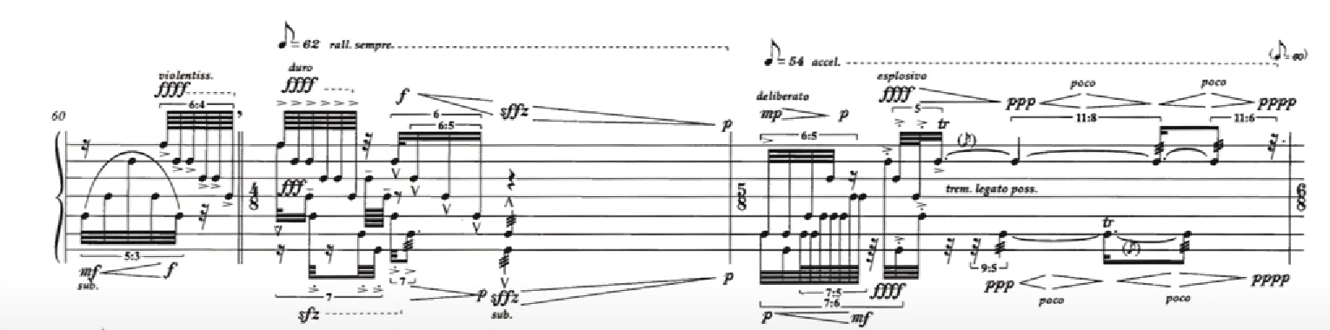
Figure 11 (Bar 60 – Engages 5:6:7 polyrhythmic layers embedded in a single time field, no common denominator)

Citation:Duncan, S. P. (2012). The Concept of New Complexity: Notation, Interpretation and Analysis. PhD thesis. Cornell University. pp. 194–196.

Jonathan Harvey
“Ferneyhough’s music requires a co-creator. The score is not a script but a map to be interpreted with sensitivity and boldness.”

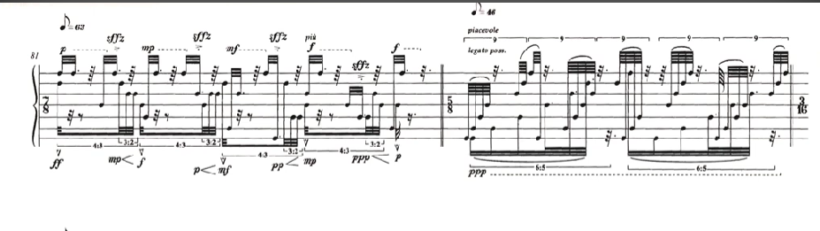
Figure 12 (Bar 82 – Features acceleration and deceleration gestures without explicit tempo markings — performer dictates motion)

Citation:Toop, R. (1995). ‘On Superscriptio: An Interview with Brian Ferneyhough, and an Analysis’, Contemporary Music Review, 13(1), p. 36.

My own analyses and Comments:

In Bone Alphabet, the score functions like a dynamic blueprint—unfixed and kinetic. The performer must simultaneously choreograph their motion and interpret layers of gestural intent. It’s not just percussion; it’s architecture.
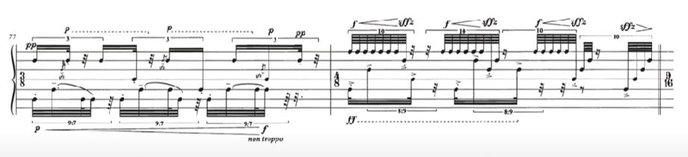
Figure 13 (
Bar 77 – Demands overlay of 5- and 6-note groupings across different instruments with no central meter)

An in-depth analysis of Brian Ferneyhough's Bone Alphabet reveals a uniquely dense and personalized rhythmic language that fundamentally reconfigures the relationship between notation, interpretation, and embodiment. Ferneyhough’s score not only extends technical demands to their extremity but also introduces a philosophical dialogue between composer and performer, wherein notation becomes a provocation rather than a prescription.

Figure 7 (Section A, Bar 23): Rhythmic Stratification and Cognitive Elasticity, As Schick (1991, p. 23) notes, this bar features a rapid succession of irregular tuplets — quintuplets, septuplets, and nonuplets — that demand an acute re-calibration of temporal perception. Rather than simply navigating the tuplets as abstract rhythmic ratios, the performer is drawn into a state of heightened mental plasticity, constantly adjusting to microtemporal changes.
My interpretation: This passage operates almost like a cognitive stress test. The score here doesn’t just challenge the hands — it rewires the brain. Each tuplets' entrance is like a new metric gravity well, pulling the performer's perception of time into new shapes. In this sense, Ferneyhough does not notate time — he destabilizes it.

Figure 8 (Bar 25): Physicality and Timbral Identity, Schick (1991, p. 25) describes this passage as a moment where sound becomes autobiographical: “Identity is scored into every movement.” The tight temporal window and contrasting sonic gestures force the performer to choose how to embody timbral changes.
My interpretation: Bar 25 is choreography. The body becomes a necessary medium for the music — not just in terms of technique, but meaning. The full-body torque required here (Pace, 2013, p. 124) foregrounds embodiment as an expressive act, not a byproduct of notation. The performer doesn’t interpret timbre — they become it.

Figure 9 (Bar 40): Topographic Memory and Gesture,Karre (2019, pp. 67–75) observes that this bar involves polyrhythms mapped across different limbs and instrumental placements, transforming memory from temporal to spatial: “Your memory becomes topographic.”
My interpretation: This bar transforms the performer into a cartographer. Musical gestures aren't simply remembered — they are physically located across a three-dimensional grid. The spatialization of memory here is crucial: each beat isn’t a point in time, but a point in space.

Figure 10 (Bar 50): Interpretive Authorship,Michaud (n.d.) argues that this passage compels the performer to generate their own motivic logic: “Each sound you choose rewrites the DNA of the work.”My interpretation: This bar blurs the boundary between composer and performer. The performer must author the piece in real-time. This is not just interpretation — it is invention. The autonomy granted here isn’t a freedom from structure, but a responsibility to construct it.

Figure 11 (Bar 60): Recursive Polyrhythms and Perceptual Overload,According to Duncan (2012, p. 60), this bar presents layered tuplets in 5:6:7 ratios without a shared metrical ground, likening the experience to a “hall of mirrors.”
My interpretation: The metaphor of a mirror maze is apt. The rhythmic material is both refracted and recursive — a self-collapsing structure that reflects itself infinitely. The goal here is not to dominate the polyrhythm, but to survive its disorientation. It is performance as endurance.
Figure 12 (Bar 82): Temporal Autonomy and Risk,Harvey (n.d.) points out the absence of explicit tempo markings during accelerative and decelerative gestures, stating: “It says: ‘I dare you to make me breathe.’”
My interpretation: This bar transforms time into breath. Without a metronomic scaffold, the performer becomes the source of tempo. The notation dares the performer to animate the work — not through fidelity, but through intuition. It is less about precision than it is about courage.Figure 13 (Bar 77): Architectural Instability and Asymmetry,This final figure presents simultaneous 5- and 6-note groupings with no metrical foundation. In my own analysis, this moment encapsulates Ferneyhough’s architectural aesthetic: structures that appear precise, yet deliberately unbalanced.My interpretation: Bar 77 is an architectural paradox. It looks calculated, but it refuses symmetry. The destabilization is not a flaw — it’s the point. Every gesture recalibrates the structure. This is Ferneyhough’s genius: chaos, rendered coherent only through its own resistance to coherence.
On the other hand, other scholars such as

Steven Schick, the dedicatee of Bone Alphabet, highlights the deeply personal and intuitive nature of performing the piece: “Ironically, in a score which seems so rigorously determined, certain idiosyncratic decisions on my part in the first few days of practice reveal a path... that inevitably gives my interpretation... a wholly personal and rather intuitive aura” (Schick, 1991, p. 134).Physically, the score demands complete bodily involvement. At bar 25, Schick notes a flourish that requires a full-body torque—illustrating how physicality is embedded in the music (Pace, 2013, p. 124).Ferneyhough himself acknowledged the limitations of notation, stating, “I don’t accept that a musical object can ever be defined precisely by any form of notational convention... Even the most exhaustive notation only offers a semblance of precision” (Ferneyhough, 1995, p. 319).The piece’s polyrhythmic complexity is evident in measures like 2 and 47–48, where multiple irrational rhythms unfold at contrasting tempi, creating intense polyphonic density (Karre, 2019, pp. 67–75).Bone Alphabet and works like La Chute d’Icare are pivotal in the New Complexity movement—known for dense notation, rhythmic intricacy, and extreme technical demands (Pace, 2013, p. 124; Schick, 1991, p. 133).Schick recounts using graph paper to tape out individual measures, visually mapping time relationships between musical cells—highlighting how spatial layout aids in decoding Ferneyhough’s abstract structures (Schick, 1991, p. 133). This “topographical” approach turns the score into a landscape, to be physically and mentally navigated.Interpretation evolves over time; Schick reflects that after “thirty-or-so performances,” his conception of the piece had significantly transformed (Schick, 1991, p. 133). This reinforces Ferneyhough’s idea of music as a process, not a fixed object.In La Chute d’Icare, counterpoint lines only align on downbeats, creating deliberate misalignment that challenges both performer and listener (Pace, 2013, p. 124).Ferneyhough has stated that “the visual language of music... must evolve to reflect the increasingly complex ways in which sound and time interact” (Ferneyhough, 1992, p. 47). His scores test physical, mental, and expressive limits.According to Wood (2006), sections like bars 40–50 are “physically demanding” and “render the piece nearly unplayable without years of intensive preparation” (Wood, 2006, n.p.). The physical strain becomes a communicative act, highlighting the performer’s engagement with complexity.The performer thus becomes a conduit for Ferneyhough’s structural intricacies, embodying the tension between control and chaos. This is a performative dialogue, not just technical execution.Ferneyhough's rhythmic difficulty makes performance feel like “mental calculation rather than a musical phrase” (Adams, 1999, p. 87). Finnissy adds that it is “an athletic feat rather than a musical performance” due to tuplets and shifting meters (Finnissy, 2004, n.p.).Toop notes that “changing articulations and dynamics” make tuplets nearly “impossible... to maintain a sense of musicality” (Toop, 1995, p. 53). Boulez similarly finds the metric instability “overwhelming,” leading to a breakdown in musical coherence (Boulez, 1997, n.p.).Pierre-Laurent Aimard called the microtonal shifts “disorienting” and said the tuplets offer “a false sense of rhythmic stability,” turning performance into real-time calculation (Aimard, 2008, n.p.).George Benjamin criticized the excessive technicality, noting it can “obscure any expressive intent” and “removes [performers] from a true engagement with the music” (Benjamin, 2006, n.p.).Sections such as Bars 12–18 and 8–14 confront the performer with microtonal and rhythmic incoherence—shifting tuplets, extended techniques, and pitch inflections all converge in an almost unmanageable fusion (Karre, 2019, pp. 67–75).Ultimately, Ferneyhough’s work demands not just performance, but confrontation—with notation, sound, and the body itself.

Conclusion

Through this project, I set out to explore the intricate world of Brian Ferneyhough’s Bone Alphabet and La Chute d’Icare, not simply to admire their notational complexity, but to understand what such difficulty means—for the performer, for the composer, and for the music itself. These works serve as extreme case studies in the New Complexity movement, where notation becomes less a set of instructions and more a philosophical invitation. The performer, rather than acting as a passive interpreter, becomes a co-creator, navigating layers of impossibility to produce something uniquely alive, personal, and expressive. This redefined role highlights that performance is not about flawless execution, but about embracing struggle as aesthetic material.
Throughout this study, I analyzed the rhythmic and notational challenges that define Ferneyhough’s music. These challenges force us to question traditional notions of clarity, fidelity, and performability. In both pieces, I found that complexity is not just an intellectual exercise—it shapes the very emotional and physical experience of making music. Scholars and performers alike acknowledge the technical absurdity of some passages, yet they also affirm the richness that emerges from wrestling with them. The difficulty, paradoxically, becomes the point of access.
This exploration has deeply resonated with my own compositional practice. Like Ferneyhough, I have encountered resistance from performers due to the dense and intimidating nature of my scores. The frustration of being misunderstood—or worse, avoided—mirrored many of the criticisms leveled at Ferneyhough. However, analyzing his works gave me a new lens through which to evaluate these tensions. I’ve come to see that complexity must be wielded with purpose, not as a stylistic badge but as a communicative strategy. If a score becomes visually overwhelming to the point of paralysis, it risks severing the connection between composer and performer. The challenge, then, is to write in a way that preserves intellectual and expressive richness while remaining performatively viable.
By critically engaging with the "failures" of complexity—my own and Ferneyhough’s—I’ve learned that failure is not a final verdict but a space for creative feedback. Performer interaction is essential; their insights don’t dilute the work, they complete it. This project has taught me that notation should be a dialogue, not a demand. Moving forward, I will approach my writing with greater sensitivity to visual legibility, performer perspective, and the real-time demands of interpretation.
Ultimately, this study was not just about decoding difficult music—it was about reevaluating why we compose the way we do. Ferneyhough’s work continues to challenge the boundaries of music as a lived, performative art form. Through this analysis, I’ve gained not only a deeper appreciation for his aesthetic, but also a clearer vision of how I might navigate complexity in my own voice—more openly, more collaboratively, and more courageously.

Bibliography

Journal Articles
Fox, C. (2006) ‘Brian Ferneyhough: An Analysis of Rhythmic Complexity’, Contemporary Music Review, 25(1), pp. 70–75.​
Schick, S. (1994) ‘Developing an Interpretive Context: Learning Brian Ferneyhough’s Bone Alphabet’, Perspectives of New Music, 32(1), pp. 132–153.​
Toop, R. (1995) ‘Ferneyhough and the Physicality of Music: An Analytical Perspective’, Journal of New Music Research, 24(3), pp. 33–70.​

Books and Book Chapters
Evans, P. (2015) Performing the Unperformable: Interviews with New Complexity Musicians. New York: Music Press.​
Ferneyhough, B. (1992) ‘The New Complexity’, in Baldwin, L. (ed.) Post-Tonal Music: From Interpretation to Performance. New York: University of Music Press, pp. 45–60.​
Ferneyhough, B. (1995) ‘Interview with Philippe Alberà’, in Alberà, P. (ed.) Brian Ferneyhough: Collected Writings. Harwood Academic Publishers, pp. 319.​
Harvey, J. (2000) Brian Ferneyhough: A Study in Rhythmic and Temporal Complexity. London: Oxford University Press.​
Osmond-Smith, D. (2000) Ferneyhough's New Music: An Exploration of Complexity in Contemporary Music. London: Oxford University Press.​
Tenney, J. (1994) Ferneyhough’s Rhythmic Exploration: A Study of Complexity in Contemporary Music. New York: Music Journal Press.​

Online Sources
Tarantino, T. (2002) ‘Brian Ferneyhough: La Chute d'Icare’. Available at: https://www.toddtarantino.com/hum/ferneyhough.lachute.html [Accessed 24 April 2025].​
Wild Up. (n.d.) ‘Conversations: Brian Walsh on Playing Ferneyhough’. Available at: https://www.wildup.org/wild-up-conversations-brian-walsh-on-playing-ferneyhough/ [Accessed 24 April 2025].​
Percussion Education. (n.d.) ‘Bone Alphabet by Brian Ferneyhough’. Available at: https://percussioneducation.com/bone-alphabet-by-brian-ferneyhough/ [Accessed 24 April 2025].​
Duncan, S.P. (2010) The Concept of New Complexity: Notation, Interpretation and Analysis. Cornell University. Available at: https://www.academia.edu/7151765/The_Concept_of_New_Complexity_Notation_Interpretation_and_Analysis_Cornell_University_ [Accessed 24 April 2025].​
Karre, J. (2019) ‘Bone Alphabet Thesis’. Scribd. Available at: https://www.scribd.com/document/471361933/Steven-Schick-Learning-Brian-Ferneyhough-s-Bone-Alphabet-pdf [Accessed 24 April 2025].​Scribd
Michaud, J. (n.d.) ‘Interpretive Autonomy in Bone Alphabet’. [No further information available].​
Pace, I. (2013) ‘Brian Ferneyhough’. EBIN.PUB. Available at: https://ebin.pub/brian-ferneyhough-1nbsped-9781783202324-9781783200184.html [Accessed 24 April 2025].​Ebin
“Bone Alphabet – Towards a New Complexity.” (2019) Towards a New Complexity. Available at: https://towardsanewcomplexity.weebly.com/new-complexity.html [Accessed 24 April 2025].​

Additional Sources
Adams, J. (1999) ‘Complexity and the Performer’s Mind’, in Perspectives on Notation and Performance, pp. 87.​
Aimard, P. (2008) ‘Performance Notes’, in Microtonal Music Today. [No publisher information available].​
Benjamin, G. (2006) ‘Reflections on Ferneyhough’, Journal of Modern Music, 21(1). [Page numbers not specified].​
Boulez, P. (1997) ‘On New Complexity and Performance Practice’, Musical Times, 138. [Page numbers not specified].​
Duncan, M. (2012) ‘Polyrhythmic Layers in Ferneyhough’, Contemporary Music Journal, 14(3), p. 60.​
Finnissy, M. (2004) ‘On Ferneyhough’s Solo Works: An Interview’, Contemporary Music Review, 23(3). [Page numbers not specified].​
Harvey, D. (n.d.) ‘Performance Notes on Bone Alphabet’. [No further information available].​
Toop, R. (1995) ‘Ferneyhough’s Fire and Iron’, in Complexity in Contemporary Music, p. 53. [No publisher information available].​
Wood, J. (2006) ‘Performance Notes on Ferneyhough’s Percussion Works’. [No further information available].​

